BOOKING FORM

IGI User Group Meeting at Hallsannery, Bideford, Devon, EX39 5HE, UK on Tuesday 25th June 2024

IGI Machine Learning Meeting at Hallsannery, Bideford, Devon, EX39 5HE, UK on Wednesday 26th June 2024

These meetings are free of charge for all users current with Support and Maintenance of IGI software. (Lunch and Dinner is included for each day) Please see the programme for all timings, when available.

NAME:

COMPANY:

ADDRESS:

Tel:

Email:

Any special dietary requirements:
IGI user group Meeting | Yes / No Tuesday 25th June 2024 all day
Machine Learning Meeting | Yes / No Wednesday 26th June 2024 all day
Room required at Hallsannery House | How many rooms: No. of people:
Price | Bed and Breakfast: £120.00+VAT per person per night

Arrival day/time (from 16.00 24/06/2024)

Departure day/time (depart by 12.00 27/06/2024)
Please note that there are limited rooms available at Hallsannery, so early booking is advised. Alternative accommodation is also available in the area, please ask for the prices and details.

Please use this link to view the Hallsannery House website: https://www.hallsannery.co.uk/

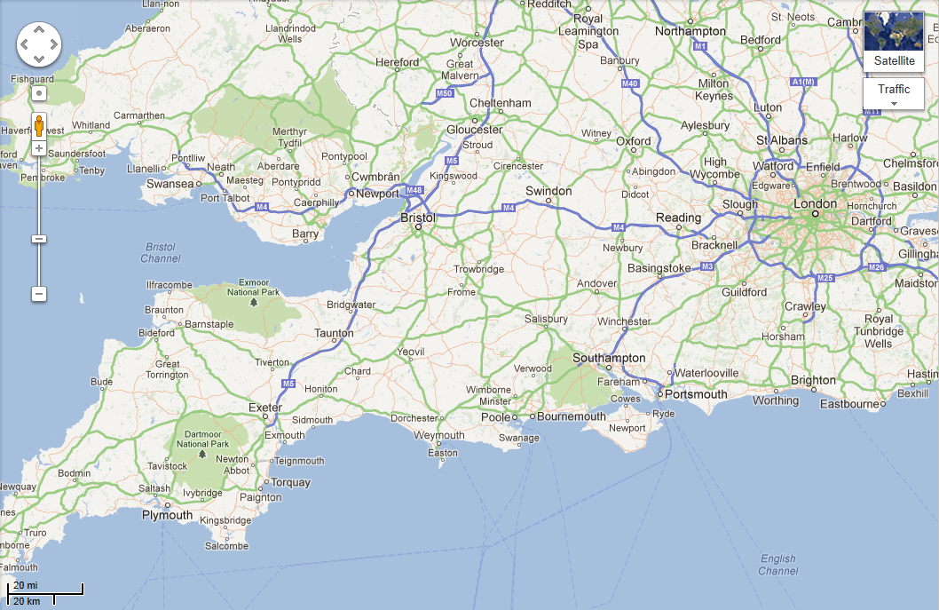
Meeting location:

Location of IGI User Group Meeting at Hallsannery, Bideford, Devon, EX39 5HE, UK
Directions: From Junction 27 of the M5, take the A361 to Barnstaple, then take the A39 to Bideford. From Bideford, take the A386 signposted to Great Torrington. IGI is located about 1 mile from Bideford. After passing two lay-bys on the left hand side and after a side road to Littleham on the right, you will find our driveway meeting the main road on the right. The sign says 'Hallsannery’.

There is parking available at Hallsannery, and taxis can be organised as needed, please contact us to arrange this.

The nearest airports to this venue are Exeter International and Bristol International. The nearest train station is Barnstaple, this is a 20 minute taxi ride from Hallsannery, or Tiverton Parkway (direct trains to London) which is an hour away by taxi.

Please return this form to:
Helen Davis: email: helendavis@igiltd.com

